UNITED STATES
SECURITIES AND EXCHANGE COMMISSION
WASHINGTON, D.C. 20549

FORM 6-K

REPORT OF FOREIGN PRIVATE ISSUER
PURSUANT TO RULE 13a-16 OR 15d-16
UNDER THE SECURITIES EXCHANGE ACT OF 1934

For the month of August 2026

Commission File Number: 001-42213

WeRide Inc.

21st Floor, Tower A, Guanzhou Life Science Innovation Center
No. 51, Luoxuan Road, Guangzhou International Biotech Island
Guangzhou 510005
People’s Republic of China
(Address of principal executive offices)

Indicate by check mark whether the registrant files or will file annual reports under cover of Form 20-F or Form 40-F.

Form 20-F ☒ Form 40-F ☐

EXPLANATORY NOTE

We submitted a monthly return form dated August 6, 2026 in relation to the movements in our authorized share capital and issued shares in July 2026 to The Stock Exchange of Hong Kong Limited. For details, please refer to Exhibit 99.1 to this current report on Form 6-K.

EXHIBIT INDEX

Exhibit  No. |  | Description
99.1 |  | Monthly Return for Equity Issuer on Movements in Securities

SIGNATURES

Pursuant to the requirements of the Securities Exchange Act of 1934, the registrant has duly caused this report to be signed on its behalf by the undersigned, thereunto duly authorized.

 | WeRide Inc.
 | By: | /s/ Jennifer Li
 | Name: | Jennifer Li
 | Title: | Chief Financial Officer

Date: August 6, 2026

Exhibit 99.1

 | 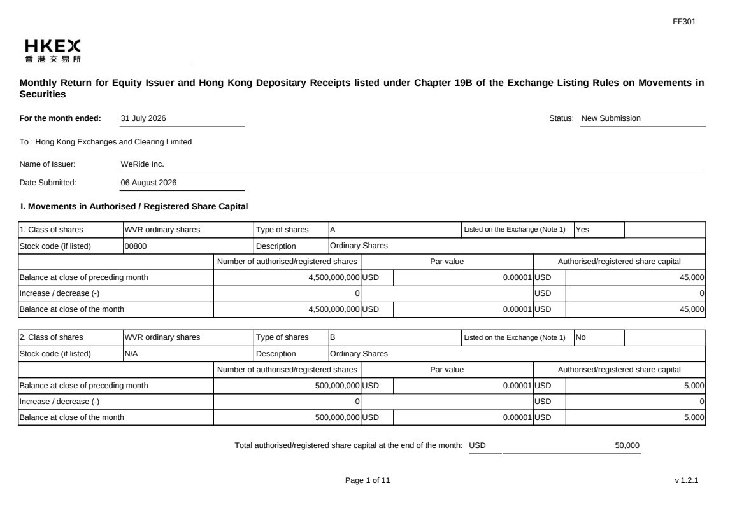 | FF301 Page 1 of 11 v 1.2.1 Monthly Return for Equity Issuer and Hong Kong Depositary Receipts listed under Chapter 19B of the Exchange Listing Rules on Movements in Securities For the month ended: 31 July 2026 Status: New Submission To : Hong Kong Exchanges and Clearing Limited Name of Issuer: WeRide Inc. Date Submitted: 06 August 2026 I. Movements in Authorised / Registered Share Capital 1. Class of shares WVR ordinary shares Type of shares A Listed on the Exchange (Note 1) Yes Stock code (if listed) 00800 Description Ordinary Shares Number of authorised/registered shares Par value Authorised/registered share capital Balance at close of preceding month 4,500,000,000 USD 0.00001 USD 45,000 Increase / decrease (-) 0 USD 0 Balance at close of the month 4,500,000,000 USD 0.00001 USD 45,000 2. Class of shares WVR ordinary shares Type of shares B Listed on the Exchange (Note 1) No Stock code (if listed) N/A Description Ordinary Shares Number of authorised/registered shares Par value Authorised/registered share capital Balance at close of preceding month 500,000,000 USD 0.00001 USD 5,000 Increase / decrease (-) 0 USD 0 Balance at close of the month 500,000,000 USD 0.00001 USD 5,000 Total authorised/registered share capital at the end of the month: USD 50,000
 | 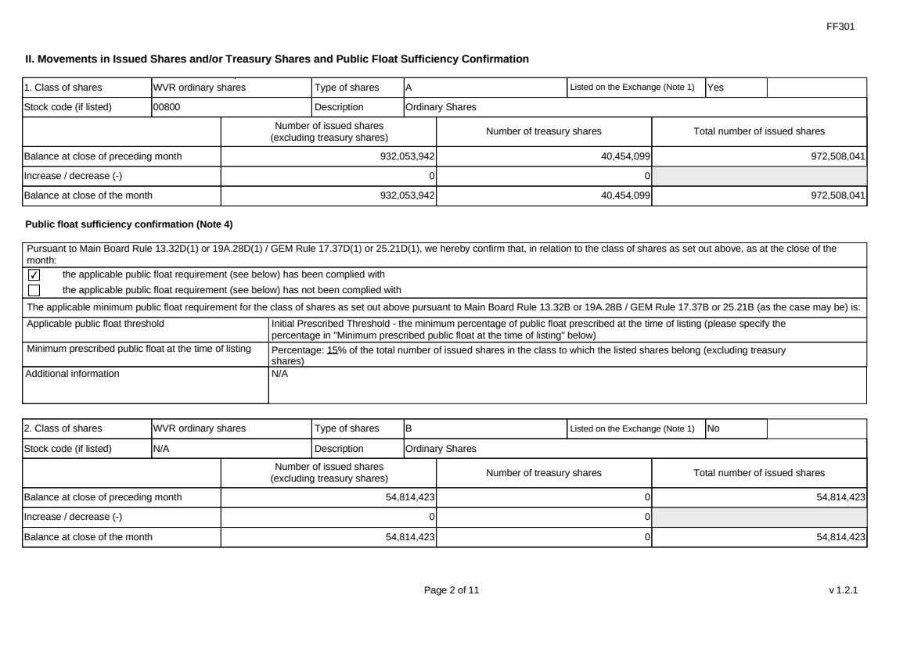 | FF301 Page 2 of 11 v 1.2.1 II. Movements in Issued Shares and/or Treasury Shares and Public Float Sufficiency Confirmation 1. Class of shares WVR ordinary shares Type of shares A Listed on the Exchange (Note 1) Yes Stock code (if listed) 00800 Description Ordinary Shares Number of issued shares (excluding treasury shares) Number of treasury shares Total number of issued shares Balance at close of preceding month 932,053,942 40,454,099 972,508,041 Increase / decrease (-) 0 0 Balance at close of the month 932,053,942 40,454,099 972,508,041 Public float sufficiency confirmation (Note 4) Pursuant to Main Board Rule 13.32D(1) or 19A.28D(1) / GEM Rule 17.37D(1) or 25.21D(1), we hereby confirm that, in relation to the class of shares as set out above, as at the close of the month: ✔ the applicable public float requirement (see below) has been complied with the applicable public float requirement (see below) has not been complied with The applicable minimum public float requirement for the class of shares as set out above pursuant to Main Board Rule 13.32B or 19A.28B / GEM Rule 17.37B or 25.21B (as the case may be) is: Applicable public float threshold Initial Prescribed Threshold - the minimum percentage of public float prescribed at the time of listing (please specify the percentage in "Minimum prescribed public float at the time of listing" below) Minimum prescribed public float at the time of listing Percentage: 15% of the total number of issued shares in the class to which the listed shares belong (excluding treasury shares) Additional information N/A 2. Class of shares WVR ordinary shares Type of shares B Listed on the Exchange (Note 1) No Stock code (if listed) N/A Description Ordinary Shares Number of issued shares (excluding treasury shares) Number of treasury shares Total number of issued shares Balance at close of preceding month 54,814,423 0 54,814,423 Increase / decrease (-) 0 0 Balance at close of the month 54,814,423 0 54,814,423
 | 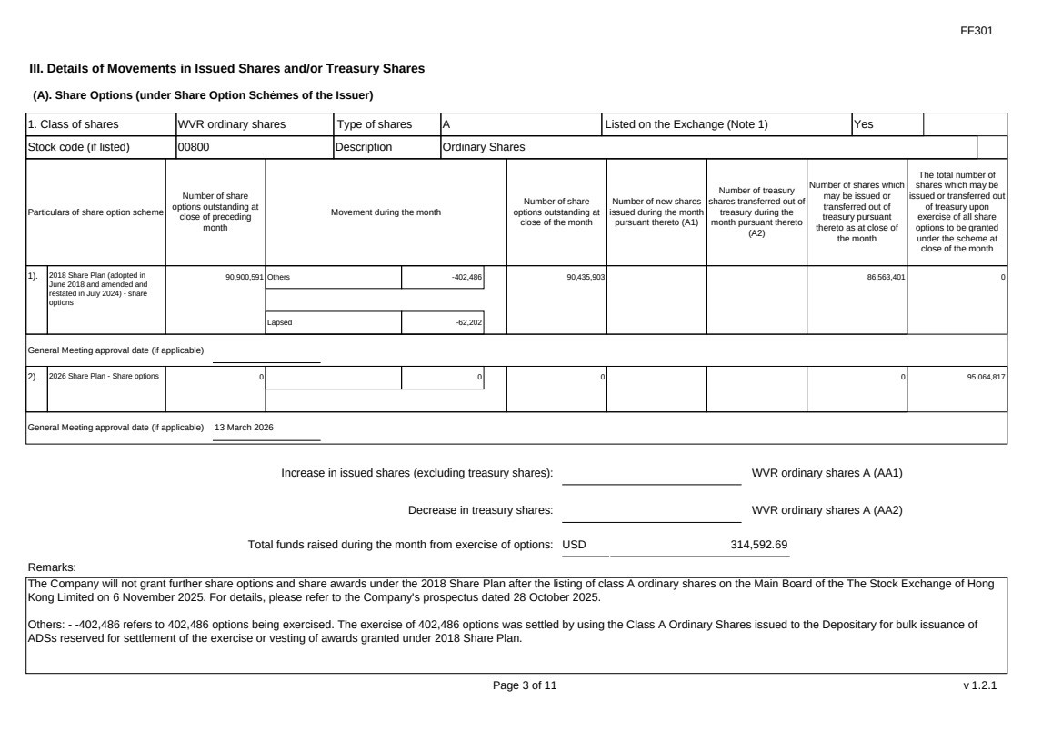 | FF301 Page 3 of 11 v 1.2.1 III. Details of Movements in Issued Shares and/or Treasury Shares (A). Share Options (under Share Option Schemes of the Issuer) 1. Class of shares WVR ordinary shares Type of shares A Listed on the Exchange (Note 1) Yes Stock code (if listed) 00800 Description Ordinary Shares Particulars of share option scheme Number of share options outstanding at close of preceding month Movement during the month Number of share options outstanding at close of the month Number of new shares issued during the month pursuant thereto (A1) Number of treasury shares transferred out of treasury during the month pursuant thereto (A2) Number of shares which may be issued or transferred out of treasury pursuant thereto as at close of the month The total number of shares which may be issued or transferred out of treasury upon exercise of all share options to be granted under the scheme at close of the month 1). 2018 Share Plan (adopted in June 2018 and amended and restated in July 2024) - share options 90,900,591 Others -402,486 Lapsed -62,202 90,435,903 86,563,401 0 General Meeting approval date (if applicable) 2). 2026 Share Plan - Share options 0 0 0 0 95,064,817 General Meeting approval date (if applicable) 13 March 2026 Increase in issued shares (excluding treasury shares): WVR ordinary shares A (AA1) Decrease in treasury shares: WVR ordinary shares A (AA2) Total funds raised during the month from exercise of options: USD 314,592.69 Remarks: The Company will not grant further share options and share awards under the 2018 Share Plan after the listing of class A ordinary shares on the Main Board of the The Stock Exchange of Hong Kong Limited on 6 November 2025. For details, please refer to the Company's prospectus dated 28 October 2025. Others: - -402,486 refers to 402,486 options being exercised. The exercise of 402,486 options was settled by using the Class A Ordinary Shares issued to the Depositary for bulk issuance of ADSs reserved for settlement of the exercise or vesting of awards granted under 2018 Share Plan.
 | 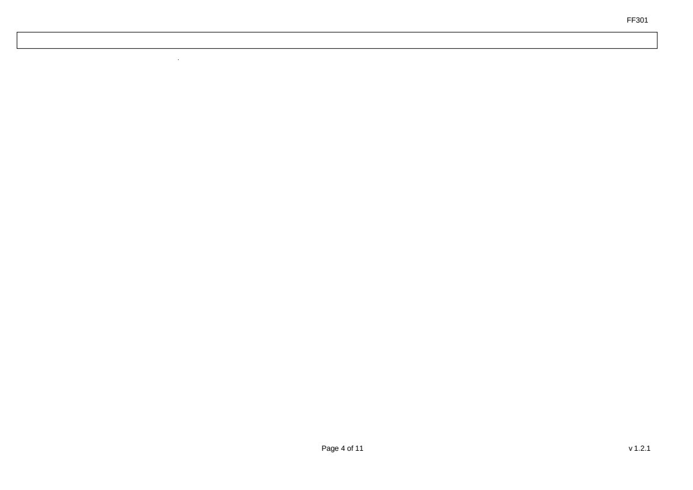 | FF301 Page 4 of 11 v 1.2.1
 |  | FF301 Page 5 of 11 v 1.2.1 (B). Warrants to Issue Shares of the Issuer Not applicable
 | 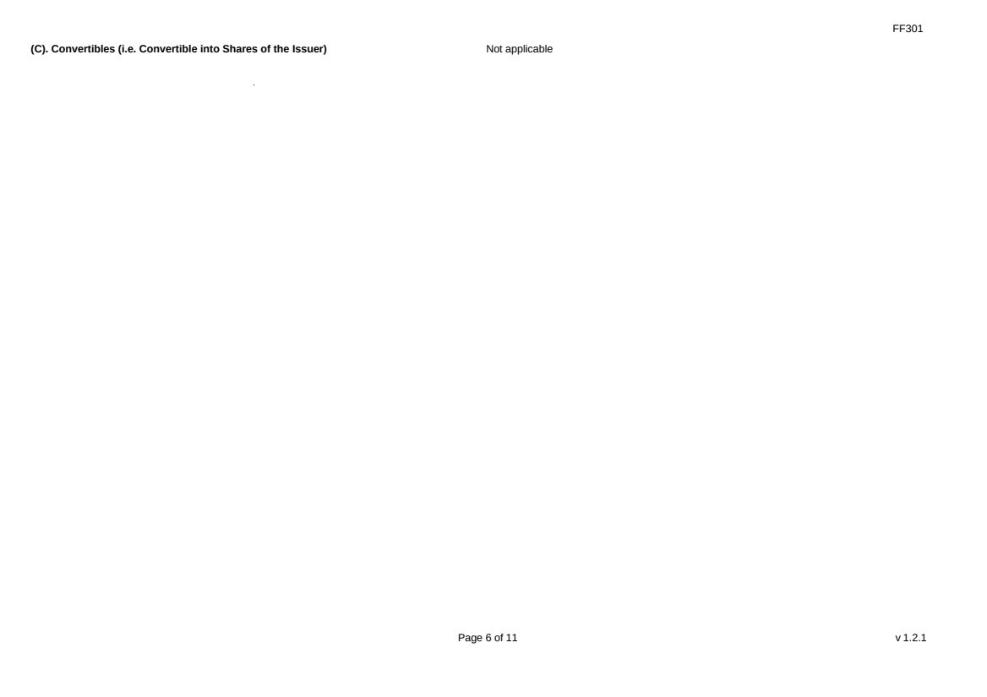 | FF301 Page 6 of 11 v 1.2.1 (C). Convertibles (i.e. Convertible into Shares of the Issuer) Not applicable
 | 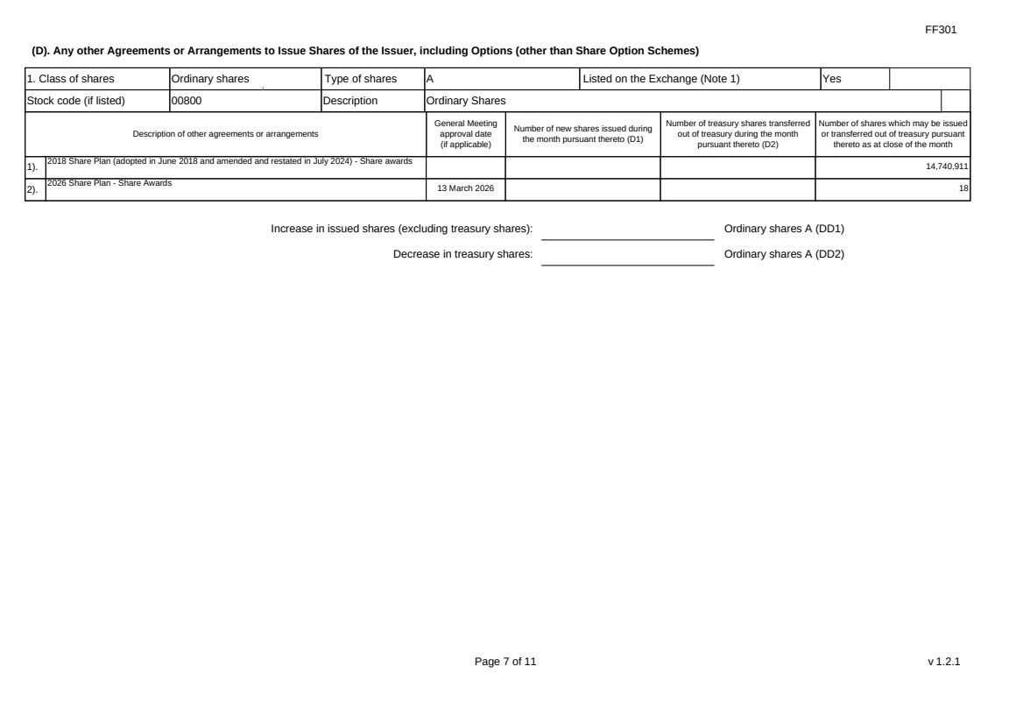 | FF301 Page 7 of 11 v 1.2.1 (D). Any other Agreements or Arrangements to Issue Shares of the Issuer, including Options (other than Share Option Schemes) 1. Class of shares Ordinary shares Type of shares A Listed on the Exchange (Note 1) Yes Stock code (if listed) 00800 Description Ordinary Shares Description of other agreements or arrangements General Meeting approval date (if applicable) Number of new shares issued during the month pursuant thereto (D1) Number of treasury shares transferred out of treasury during the month pursuant thereto (D2) Number of shares which may be issued or transferred out of treasury pursuant thereto as at close of the month 1). 2018 Share Plan (adopted in June 2018 and amended and restated in July 2024) - Share awards 14,740,911 2). 2026 Share Plan - Share Awards 13 March 2026 18 Increase in issued shares (excluding treasury shares): Ordinary shares A (DD1) Decrease in treasury shares: Ordinary shares A (DD2)
 | 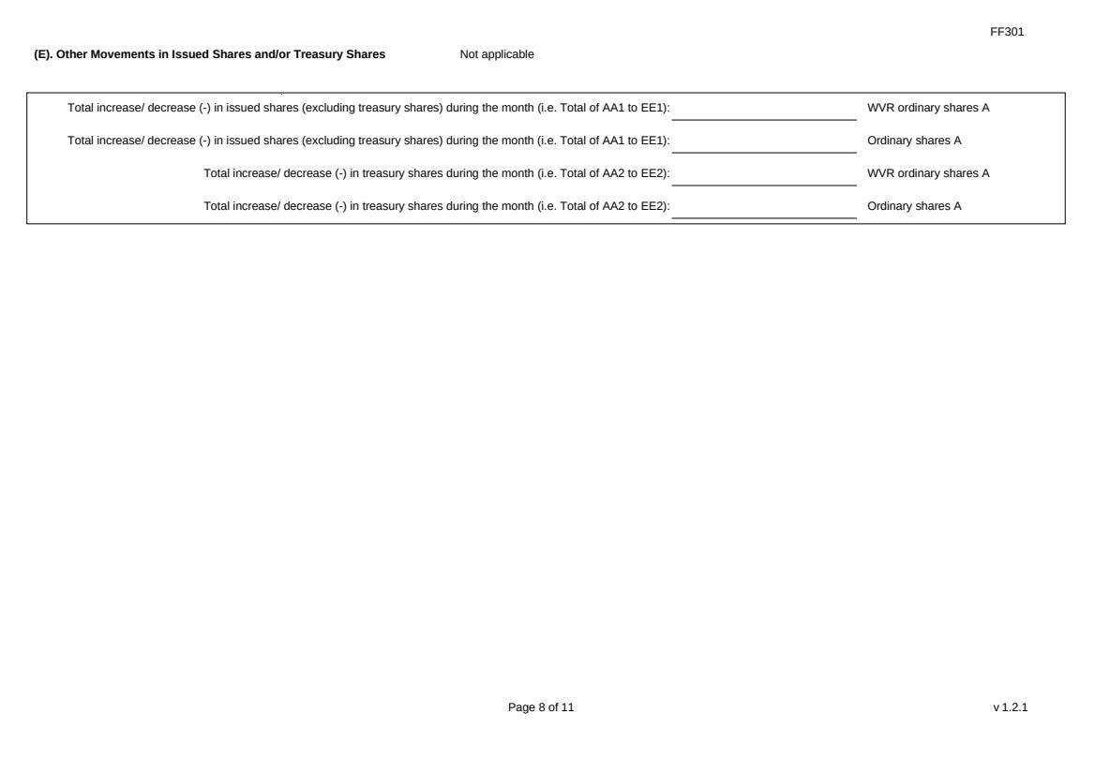 | FF301 Page 8 of 11 v 1.2.1 (E). Other Movements in Issued Shares and/or Treasury Shares Not applicable Total increase/ decrease (-) in issued shares (excluding treasury shares) during the month (i.e. Total of AA1 to EE1): WVR ordinary shares A Total increase/ decrease (-) in issued shares (excluding treasury shares) during the month (i.e. Total of AA1 to EE1): Ordinary shares A Total increase/ decrease (-) in treasury shares during the month (i.e. Total of AA2 to EE2): WVR ordinary shares A Total increase/ decrease (-) in treasury shares during the month (i.e. Total of AA2 to EE2): Ordinary shares A
 | 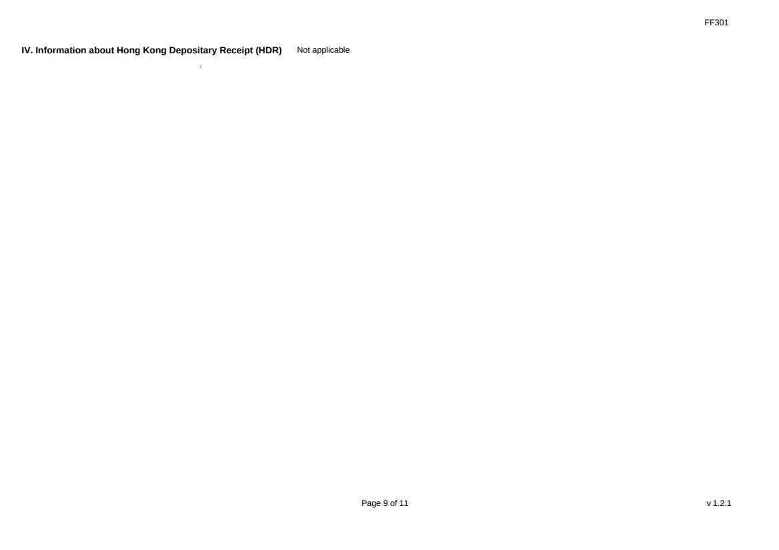 | FF301 Page 9 of 11 v 1.2.1 IV. Information about Hong Kong Depositary Receipt (HDR) Not applicable
 | 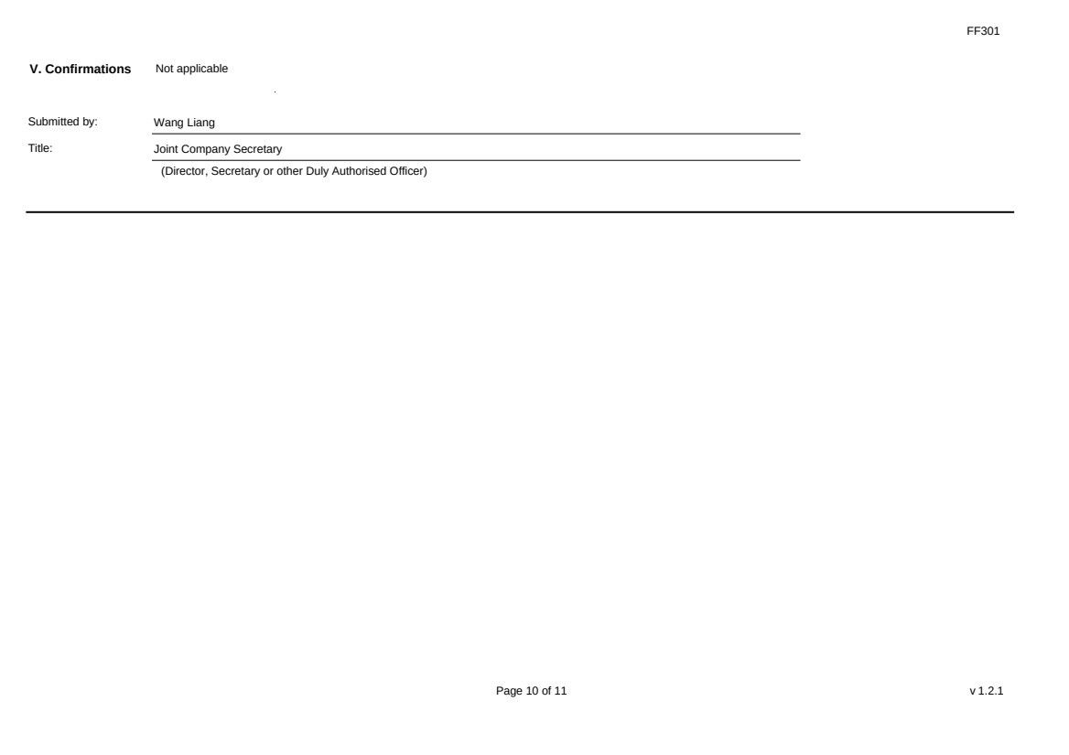 | FF301 Page 10 of 11 v 1.2.1 V. Confirmations Not applicable Submitted by: Wang Liang Title: Joint Company Secretary (Director, Secretary or other Duly Authorised Officer)
 | 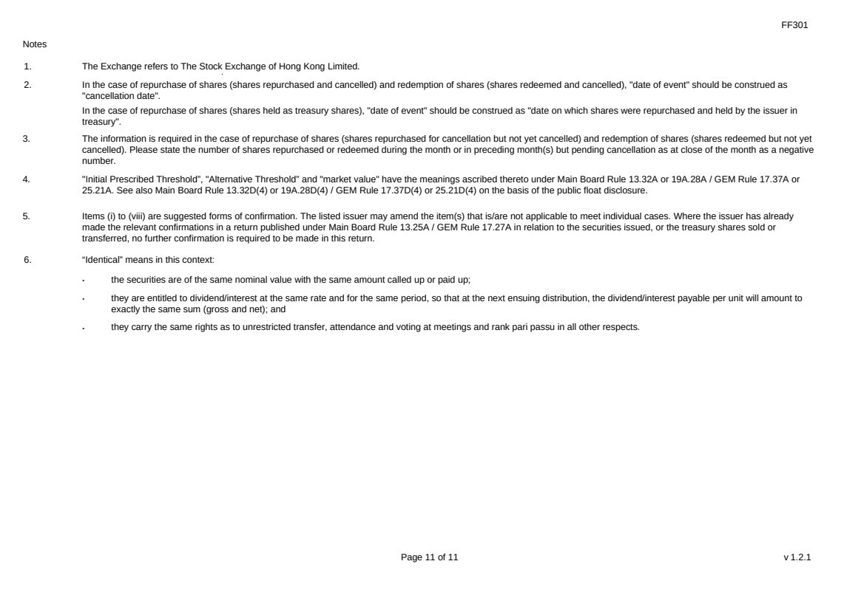 | FF301 Page 11 of 11 v 1.2.1 Notes 1. The Exchange refers to The Stock Exchange of Hong Kong Limited. 2. In the case of repurchase of shares (shares repurchased and cancelled) and redemption of shares (shares redeemed and cancelled), "date of event" should be construed as "cancellation date". In the case of repurchase of shares (shares held as treasury shares), "date of event" should be construed as "date on which shares were repurchased and held by the issuer in treasury". 3. The information is required in the case of repurchase of shares (shares repurchased for cancellation but not yet cancelled) and redemption of shares (shares redeemed but not yet cancelled). Please state the number of shares repurchased or redeemed during the month or in preceding month(s) but pending cancellation as at close of the month as a negative number. 4. "Initial Prescribed Threshold”, "Alternative Threshold” and "market value" have the meanings ascribed thereto under Main Board Rule 13.32A or 19A.28A / GEM Rule 17.37A or 25.21A. See also Main Board Rule 13.32D(4) or 19A.28D(4) / GEM Rule 17.37D(4) or 25.21D(4) on the basis of the public float disclosure. 5. Items (i) to (viii) are suggested forms of confirmation. The listed issuer may amend the item(s) that is/are not applicable to meet individual cases. Where the issuer has already made the relevant confirmations in a return published under Main Board Rule 13.25A / GEM Rule 17.27A in relation to the securities issued, or the treasury shares sold or transferred, no further confirmation is required to be made in this return. 6. “Identical” means in this context: ． the securities are of the same nominal value with the same amount called up or paid up; ． they are entitled to dividend/interest at the same rate and for the same period, so that at the next ensuing distribution, the dividend/interest payable per unit will amount to exactly the same sum (gross and net); and ． they carry the same rights as to unrestricted transfer, attendance and voting at meetings and rank pari passu in all other respects.

